Bansilal Ramnath Agarwal Charitable Trust’s

VISHWAKARMA INSTITUTE OF TECHNOLOGY, PUNE-37


(An Autonomous Institute of Savitribai Phule University)

Department of Artificial Intelligence & Data Science

Division | AIDS-A
Name | Atharva Arun Raut
Roll.no | 21
PRN | 12310801
Batch | B-1

- Basic Commands used in linux:

- The ls command in Linux

The ls command is used to list files and directories in the current working directory. This is going to be one of the most frequently used Linux commands you must know of.

The pwd command in Linux

The pwd command allows you to print the current working directory on your terminal. It’s a very basic command and solves its purpose very well.
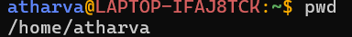

mkdir command in Linux

This mkdir command allows you to create fresh directories in the terminal itself. The default syntax is mkdir <directory name> and the new directory will be created.

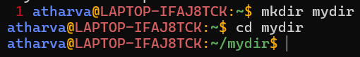

cd command in Linux

The cd command is used to navigate between directories. It requires either the full path or the directory name, depending on your current working directory.

mv command in Linux

The mv command is generally used for renaming the files in Linux.

uname command in Linux

The uname command is used to check the complete OS information of the system.
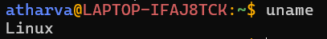

cp command in Linux

The cp command of Linux is equivalent to copy-paste and cut-paste in Windows.

cat command in Linux

The cat command is the simplest command to use when you want to see the contents of a particular file.
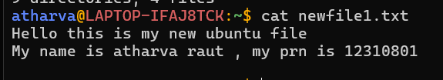

ps command in Linux

ps command in Linux is used to check the active processes in the terminal.
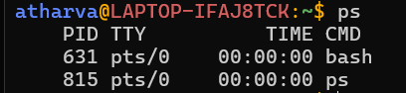

whoami command in Linux

The whoami command provides basic information that is extremely useful when working on multiple systems
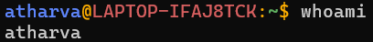

- echo command

Echo is a Unix/Linux command tool used for displaying lines of text or string which are passed as arguments on the command line

- passwd command

The passwd command sets and changes passwords for users. Use this command to change your own password or another user's password.
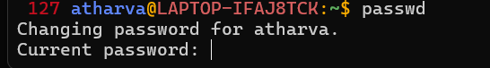

- ls -a

Lists all directories, including hidden ones (those starting with.), in the current directory.

- rm command

The 'rm' means remove. This command is used to remove a file.

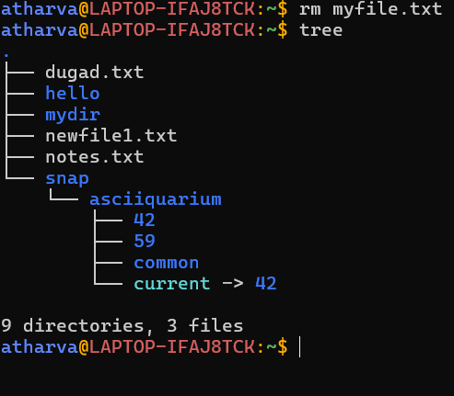

- date command

date command is used to display the system date and time. date command is also used to set date and time of the system.
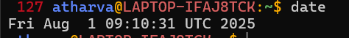

- touch command

The touch command in Linux is used to create a new empty file and to change the timestamps of existing files.

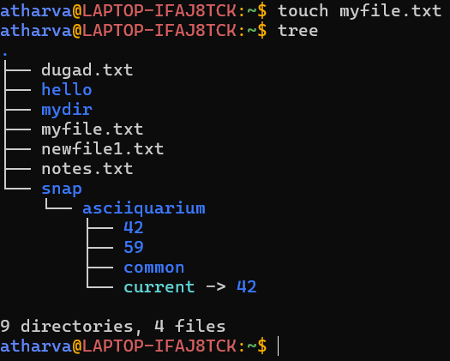

- man command

man command in Linux is used to display the user manual of any command that we can run on the terminal.

- Sort command

SORT command is used to sort a file, arranging the records in a particular order.

x

- Whereis command

whereis command is used to find the location of source/binary file of a command and manuals sections for a specified file in Linux system.
- df command

The df command displays information about total space and available space on a file system.
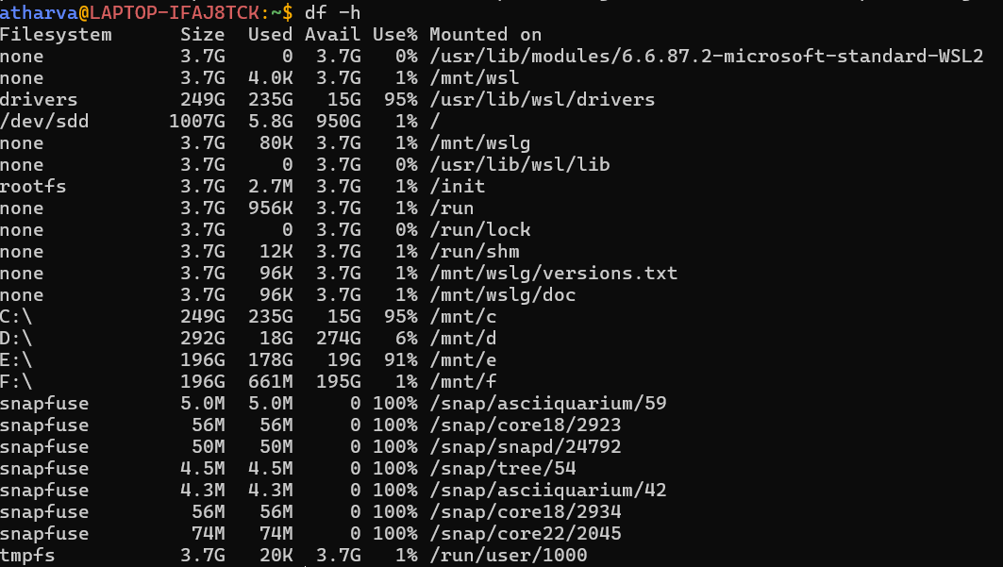

- tree command
The tree command is used to list down the files in the memory but in a tree like structure .
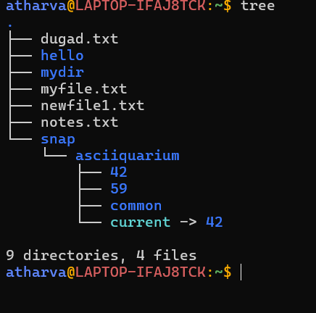

- du -sh : it summarizes the directory size
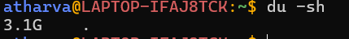
- sudo : Super user do , it executes a command with root privileges
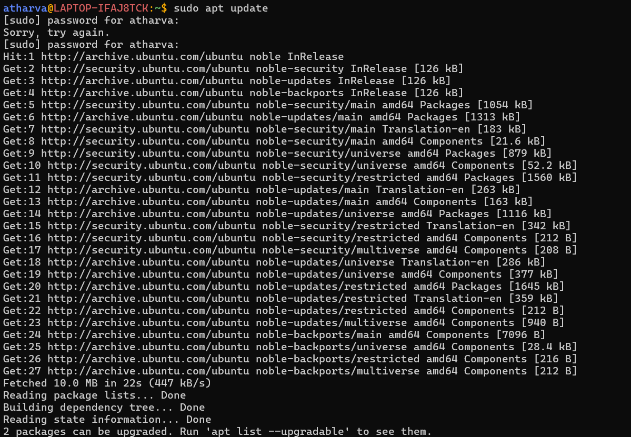

24.ping : shows the ping of the given website
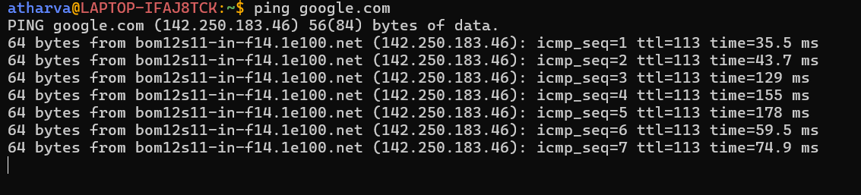

25.ip addr : shows ip address
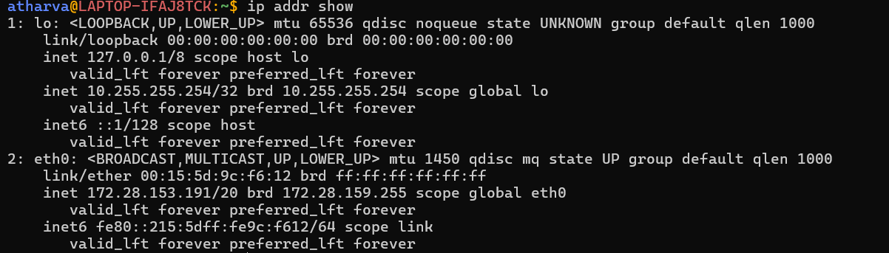

Conclusion:
I learned basic linux commands its execution and use from this assignment.

